**Sum of even numbers**

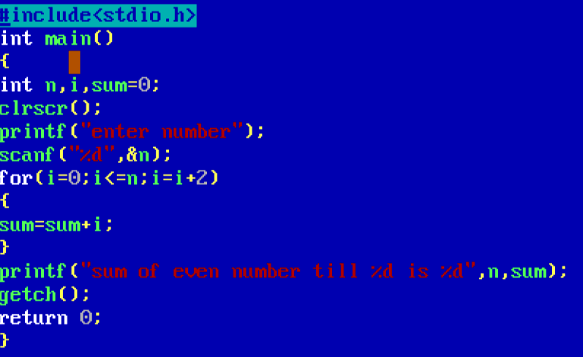

Output

